Autonomous Legged Guide Robot

First Semester Report

B. Ma, S. Zhang, X. Yao, Y. Wang, Y. Bi,  *Boston University*

**Project Summary** — The robot software to be developed will allow the legged robot to navigate through different settings, including sidewalks, hallways, stairs, etc. The robot can help blind people by following them and helping them navigate varying terrains. The cost of implementing such a robot will be significantly less than training guide dogs, and its functionality will exceed those of an electronic cane.

—————————— ◆ ——————————

# 1 Introduction - Bowen

ight is one of the most important senses in our daily life. However, for visually impaired people, even small tasks or interactions can be extremely onerous. Moreover, among all inconveniences experienced by people with visual impairment, mobility reduction has been one of the most severe issues. Scientists have been exploring numerous means to restore sufficient mobility for the visually impaired, yet all solutions used have certain limitations.

Probing canes and specially-trained guide dogs are two traditional solutions to guide those visually impaired people. Yet, the functions of canes are limited in public areas, while training guide dogs is extremely expensive. More importantly, none of the traditional solutions have the capability of navigation. Although dogs can remember some routes, the map size that dogs can remember is limited, and when changing to a new environment, a new map needs to be memorized, which can be time-consuming. The purpose of our project is to solve this issue with a better approach: a robotic navigator dog capable of shunning the drawbacks of past solutions.

To help visually impaired people move around more conveniently, our autonomous legged robot will act as a clever dog, guiding the visually impaired by giving instructions about the position of obstacles in time to veer.

Our first function is to make the robot get to a planned destination. The user interface may be operated by audio message. We will embed the ability to store and learn the map incrementally, beginning with at least a small block and expanding the range according to the process, which is the advantage over guiding dogs since dogs can’t remember the routes it hasn't gone to. And also, We will employ a legged robot in order to overcome some tough routes, including going up and down the sidewalks. Our second main function is obstacle detection and avoidance. We may use OAK-D cameras paired with machine learning training models to detect the obstacles within a certain distance and give hints back to visually impaired people when and how to veer or stop. Also, for the legged robot itself, we will first try to make it steer around the resting obstacle like a pillar and go back to its original planned route.

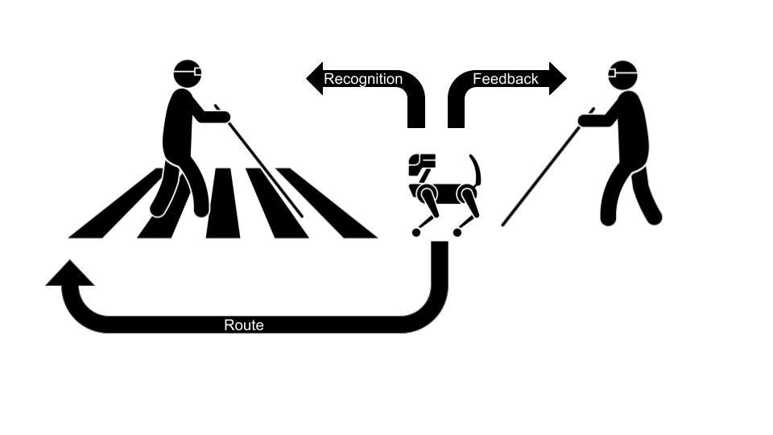

Fig 1. Schematics of basic functions of our design. During navigation, if the robot detects and recognizes the presence of a visually impaired person at a close distance, it will provide voice feedback to the owner via earphones and plan a detour to avoid collision with the person in front.

# 2 Concept Development - Xiteng

After we discussed with Prof. Ohn-Bar, we learn that our project is to solve the problem of helping the visually impaired to travel. We started developing our conceptual approach based on the problem. We started by thinking about the use case for our product. Then we develop engineering requirements based on these use cases. Specifically, we considered many scenarios in which our user, the visually impaired individual, needs to use the product.

The first use case is walking on the sidewalk. The user’s problem is that they cannot see the road and may collide with other pedestrians. To solve this problem, our product must be able to detect objects or other pedestrians–specifically other visually impaired pedestrians–in front of the user and warn the user about the object. Therefore, we added the engineering requirement of detecting objects and warning the users.

The second scenario is the user wants to travel from one place to another. The user cannot navigate themselves as they cannot check the map with their eyes. To help them resolve this problem, our product needs to be able to provide correct navigation information for the user and be able to remind them where to make turns and if they are on the correct path. As a result, we added the engineering requirement to help the user with navigation.

The third scenario is the user wants to cross a road in a traffic intersection. To solve this problem, our product needs to provide users with the traffic light information at a crosswalk. The product should also be able to remind users when the traffic light is green and safe to cross the road. Therefore, we added the engineering requirement of helping the user walk across the road.

Summarizing these requirements, we defined that our product needs to have the visual ability and the ability to recognize objects on the sidewalk. In addition, it should have the ability to communicate with the user and notify the user when needed. Moreover, it should be able to navigate the user from one place to another. Finally, it should be able to guide the user in complicated environments.

Based on the engineering requirements, we developed a system that can be carried by a mobile platform, the robot dog. The robot dog has sensors that collect data and send it to the processor, which processes it and communicates it to the user through wireless headphones. The robot dog can carry the system and walk along with the user. The robot dog’s mobility makes it possible to detect more details on the road, and it does not require the user to carry a heavy system.

# 3 System Description - Bowen

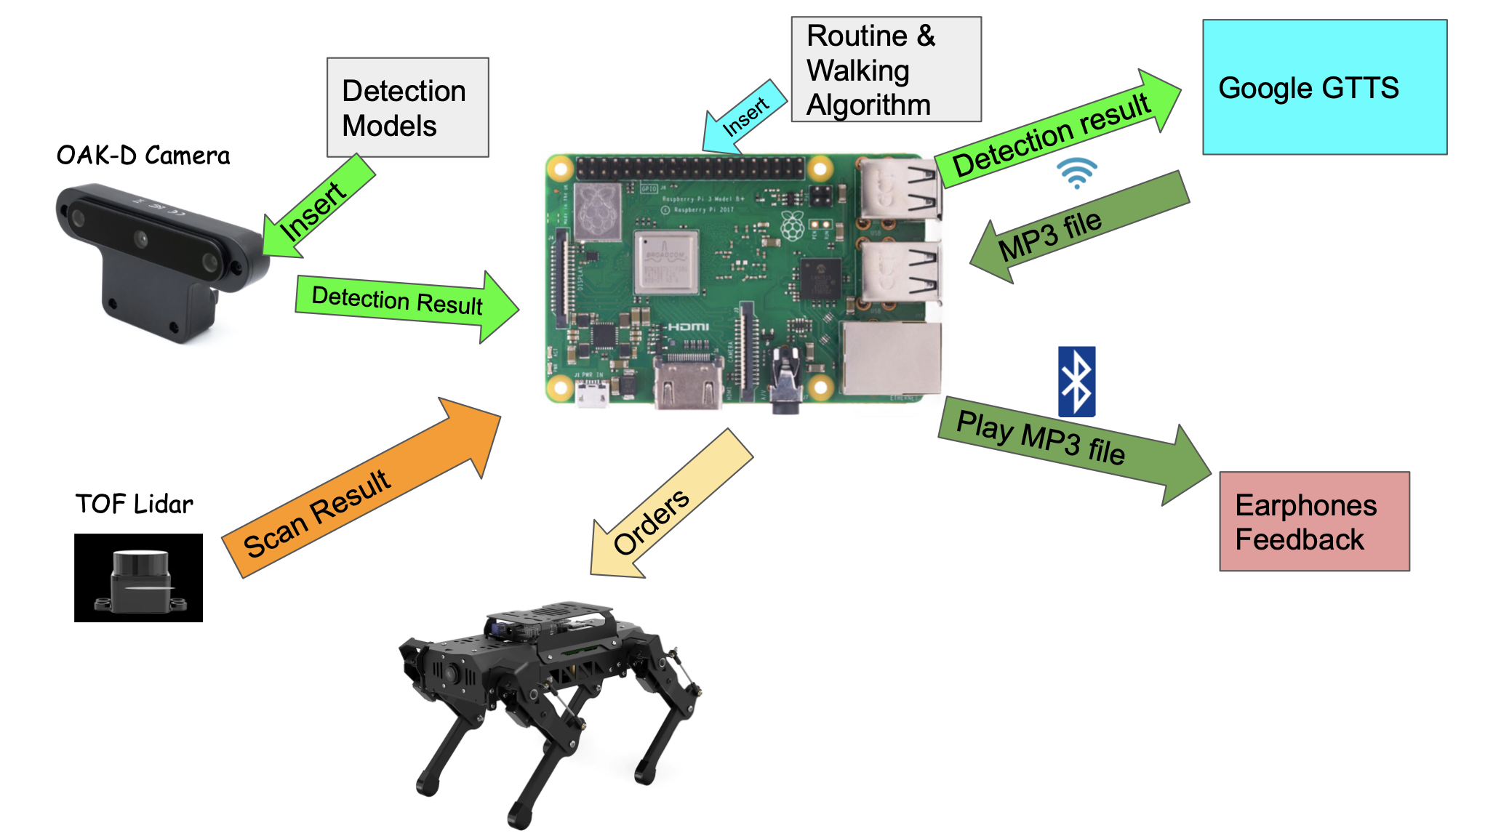

Fig 2.1 System overview of our design. The Raspberry Pi (module in the middle) is the CPU controlling all the units and modules. OAK-D Camera detects and recognizes certain objects in front of the robot, while the TOF Lidar provides 360° object detection. The results of successful detection will be passed to Google GTTS and converted into an MP3 file which will be played via earphones.

To achieve our objectives of the project. We utilize modules shown in Figure 2.1. Our CPU will be a Raspberry Pi 4, which we will access through a VNC viewer and implement the routing, object detection, and detour algorithms. There are two modules for object detection: OAK-D camera and TOF Lidar. OAK-D is embedded with a neural network processor and a detection model, YOLO V3. It is capable of object recognition, and the target could include people, canes, chairs, etc. Since the OAK-D camera could only provide a 180° scan, we will also implement a TOF Lidar which is used for 360° environment scans. The output of the two sensors will be fed back to the Raspberry Pi, and the Pi will process the output and pass it to two modules.

First, when an incoming object is present on the planned route, Raspberry Pi will convert the distance and possibly the object's category, if recognizable, to a string and pass the string to the Google GTTS module, which is accessed via Wi-Fi. Google GTTS will process the detection string and return an MP3 file containing a voice memo of the string. Once the Pi receives the MP3 file, it will pass it to the earphone module via Bluetooth, and the earphone will play the voice output.

Besides voice output, another vital action needs to be performed. When the object is within the detectable distance of the OAK-D camera, which is 7.5m, The Pi needs to run the detour algorithm, create a detour route for the robot dog and output the updated route to the robot. In this case, the robot will have sufficient time to make a detour to avoid collision with the object. Figure 2.2 demonstrates the complete workflow of our system

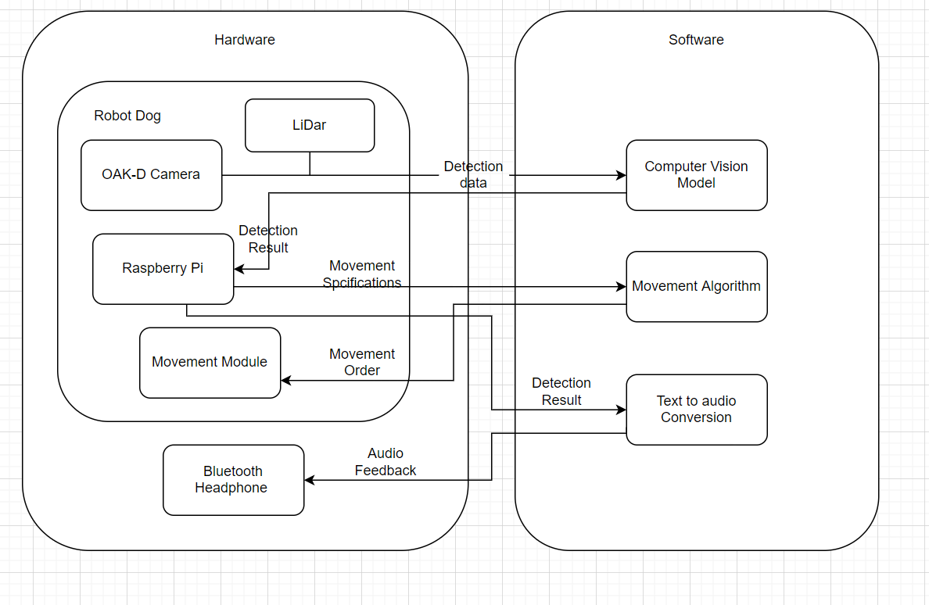

Fig 2.2 Block diagram of the autonomous legged robot. The navigation action is performed in collaboration with the four major modules inside the robot and one Bluetooth headphone worn by the user.

# 4 First Semester Progress - Shun

This semester, we focused on making each module work. We have so far been working on three modules: the Raspberry Pi, movement control, and the OAK-D camera.

**4.1 Raspberry Pi:**

Since the robot came with a Raspberry Pi as a controller, we are eager to find out the preset functions of the dog. We planned to approach the connection in three ways: wire connection, SSH, and SD card programming. However, because of the robot's physical structure, it is very hard to get the SD card out. We turn to the SSH connection with the Wifi module of the Pi. We were able to connect with the Pi via an ethernet cable. With the SSH connection, we can now modify the scripts inside and also add our scripts.

**4.2 Simulation Environment:**

The robot uses a Robot Operating System (ROS) to control the robot. This is a Python-based system. We set up two simulation environments, and we can tell the robot to perform different movements inside the environments. The first environment we set up is called Issac with Nvidia Omniverse. This is to help us learn about the ROS system and simulate some real world. scenarios. However, this environment is too GPU consuming, and we can hardly simulate our dog’s control logic since we can hardly build the same robot inside because the parameters of the motors are different. The other environment is called Gazebo, which is lighter on a scale.This simulation environment allows us to program the robot. And since the Raspberry Pi is inside the dog, we need to tear it apart during our development, so this simulation is very important for us.

**4.3 OAK-D camera:**

As the “eye” of the robot, we want this camera to detect different obstacles. We utilize not only the RGB camera to detect object classes but also the two mono cameras on the sides to detect the distance between the object and the camera. After our research and tests, we found the maximum distance for the mono camera is around 4.8 meters, and the minimum is around 0.4 meters. We can now utilize the neural network inside the camera to run detection models. For now, we use YOLO V4, but according to our client, we also need to detect the canes when another visually impaired person is coming toward the user. We probably need to find other models or add a class to the existing one. We also wrote an algorithm to transfer the detection result into the wording and utilized the Google GTTS library to transfer it into readable mp3 files. Based on our testing, we can now recognize over 10 classes, including person, TV, box, etc, very well with a low error rate.

**4.4 ROS control with Raspberry Pi:**

We dive into the Raspberry Pi and learn from some preset logic with the resources on their official website, we can now perform many movements like walking forward and backward, turning, and changing the height of the robot. With the modification of the parameters of the eight servos located on the dog’s four legs, we can make more movements in the future. We are also in the progress of designing a system to let the ROS and OAK-D cameras run simultaneously with interactions between OAK-D’s result and ROS’s control and orders. Our attempts are based on the ROS nodes architecture that allows one node to listen from the OAK-D’s program as a sensor to interact with the whole system.

# 5 Technical Plan - Yichen

## 5.1 Distance Sensor installation

## An ultrasonic transducer that can receive and inject wave sounds to calculate the distance between it and the obstacles in front of it should be selected, installed, and tested. It shall be compatible with the robot dog's size and meet weight specifications. The design should be tested early in the experiment, so other methods can be considered for replacement. Lead: Yichen; Assisting: Shun

## 5.2 ROS dog control

## A way to use the ROS system to control the movement of the robot dog should be found and tested. Everyone in the group should be familiar with the ROS system and have a great command of simulating the dog’s movement on the simulation platform. The robot dog should be able to walk, turn left, turn right and step upstairs using the ROS script. Lead: Xiteng; Assisting: Yihe

## 5.3 Google GTTS module installation

A GTTS module should be installed and tested. It should be able to transfer written words into an audio message and send it back to the airphone. It should be able to be connected to the Raspberry Pi and Bluetooth earphones so that the user can hear the information from the robot dog’s judgment. Lead: Shun; Assisting: Bowen

## 5.4 TOF/lidar Test

A test between TOF and lidar should be completed in the first several weeks. The error of the distance should be no more than 0.1 meters to ensure that the dog can send the alarming signals in time. TOF and lidar are two alternative ways to determine the distance using different schemas. Testing is necessary to select the best one. Lead: Yihe; Assisting: Yichen

**5.5 Bluetooth module installation**

A Bluetooth module should be installed and tested in the ROS system. It should be able to be connected to the Raspberry Pi and connect to certain hardware like airphones or phones with ease. Then it should work with the GTTS module to do the audio output. Lead: Bowen; Assisting: Shun

**5.6 Line Following Module installation**

The robot dog should be able to follow the line with a diameter greater than 2 centimeters on the floor and make sure the center of the robot should not stray from the line more than 3 centimeters. The robot dog should be able to turn left and right along the line. Lead: Xiteng; Assisting: Yichen

**5.7 Quick movement detection**

The robot should be able to detect an object moving vertically by its path with a velocity between 10km/h to 20 km/h and stop itself while sending the alarming signal. Lead: Shun; Assisting: Yihe

# 6 Budget Estimate - Yihe

| **Item** | **Description** | **Cost** |
| --- | --- | --- |
| 1 | Quadruped Robot Dog | $669 |
| 2 | OAK-D Sensor (from Client) | $199 |
| 3 | Monitor (to be donated) | $150 |
| 4 | HDMI Cable | $10 |
| 5 | USB Keyboard | $10 |
|  | Total Cost | $1038 |

A large portion of our budget goes to the robot dog since we need the dog to have some specific sensor such as Lidar and a high-definition camera. Those sensors can largely help us develop algorithms because of their accuracy. The next big item is also a sensor. OAK-D can provide the depth information and do image processing on its own chip, so it helps to offload some calculations from the CPU on the robot, which is also very helpful given the chip on the robot is a Raspberry Pi, which doesn’t have strong computing power. The monitor, cable, and keyboard are for development with the onboard chip.

One limitation is that we want our dog to have good mobility on multiple terrains, including on/off sidewalks, stairs, and ramps. However, the quadruped dog that is large enough to climb stairs is too expensive (around $10k). Still, we can test our algorithm on the dog we have and achieve the function we want since both dogs work with the same principle.

# 7 Attachments

## 7.1 Engineering Requirements - Bowen

## 7.1.1 Objectives

This project aims to investigate and develop the implementation of artificial intelligent robotics in the software engineering aspect. The main goal is to improve the living quality of visually impaired people, specifically in the area of daily navigation, by developing an affordable, which indicates price of no more than $750, quadrupled self-navigation robot with stable durability of over 3 years of daily usage. We believe the implementation of the OAK-D camera, TOF lidar sensor, and embedded neural network processor will already improve our product's performance in object identification and obstacle avoidance. Our product will also obtain a built-in slam map capable of storing routing information for a 500-meter radius. With the above technologies implemented, we expect our product to at least match the navigation capability of guide dogs and the durability of normal electronic canes.

## 7.1.2 Functional Requirements

In the design phase of our product, the following functional requirements should be satisfied:

1. The product shall have built-in slam maps capable of navigating to destinations within a 500m straight-line distance.
2. The product shall incorporate one or more TOF lidar sensors to detect incoming objects and obstacles within 5 meters from all directions.
3. The product shall be capable of climbing up and down normal-height sidewalks/stairs of 25cm.
4. The product shall have a waterproof level to ensure proper functionality under 5cm precipitation.
5. The product shall be capable of connecting to phones/earphones based on the latest Bluetooth 5.2 standard for sound direction.
6. The product shall offer an automatic charging station that the robot can self-charge when the battery is under 10%.

## 

## 7.1.3 Constraints and Metrics

During the actual implementation of our product, the list of constraints below should be considered:

1. The cost of all materials utilized to build the robot should not exceed $750.
2. The product should have a presentable prototype with more than 80% of functions implemented by March 31, 2023.
3. The overall weight of the product should not exceed 20 kg.
4. The durability of the product should be no less than 3 years of daily usage.
5. The product should be regulated by OSHA standards.

## 7.2 Gantt Chart – Yihe

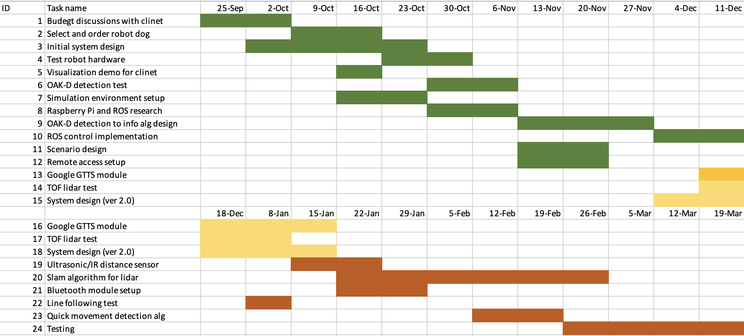

## 7.3 Other Appendices

1. IAADP, “IAADP minimum training standards for public access,” The International Association of Assistance Dog Partners (IAADP), 09-Jun-2022. [Online]. Available: https://iaadp.org/membership/iaadp-minimum-training-standards-for-public-access/. [Accessed: 14-Oct-2022].
2. Service dog certification, “How much does it cost to train a service dog,” Service Dog Certifications, 25-Feb-2022. [Online]. Available: https://www.servicedogcertifications.org/how-much-does-it-cost-to-train-a-service-dog/. [Accessed: 14-Oct-2022].
3. SuperCane, About the UltraCane. [Online]. Available: https://www.ultracane.com/about_the_ultracane. [Accessed: 14-Oct-2022].
4. OAK-D，[Online]，Available: https://docs.luxonis.com/projects/hardware/en/latest/pages/BW1098OAK.html#oak-d
5. “Ultrasonic sensor accuracy,” Senix Ultrasonic Distance and Ultrasonic Level Sensors, 30-Mar-2022. [Online]. Available: https://senix.com/ultrasonic-sensor-accuracy/. [Accessed: 14-Oct-2022].